Energy Efficiency & Electricity Bill Prediction based on ML Algorithm.

Abstract

As due to increase demand of energy and need for sustainable consumption, so electricity bill prediction and energy efficiency comes into play. The Purpose of forecasting approach help people to use electricity efficiently using the machine learning models. By using electricity consumption data , appliance usage patterns, our model predicts future electricity bill with high accuracy. It explores energy efficiency strategies by analyzing consumption trends and recommending optimal usage patterns. Our main aim is to assist consumers in better financial planning and reducing energy wastage. After demonstrating that machine learning techniques, such as regression model can significantly enhance prediction accuracy compared to traditional method. This research contributes in development of smart energy management systems, promoting sustainable energy consumption and cost-effective electricity usage.

Introduction

Energy Efficiency provides the optimize ways to save the energy and saving the electricity bill. It help the environment from the Air Pollution. Many Companies use more energy than the actual need to avoid this energy inefficiency one must invest in energy efficient Products[1]. If we prioritize energy efficiency it will help in Sustainable environment and good digital infrastructure for future . We can start with energy efficiency by saying low- or no-carbon, investing in renewable products & energy , using Smart NICs to maximize profit. Electricity Consumption in India leads to high energy consumption which include residential, industrial & commercial . It play a key role in sustainability which help in resource preservation , reducing the energy waste and motivating the people to come on renewable resources such as decreasing fossil fuels which lead to mitigating climate changes.

India Experience with substantial 20% of total electricity losses than all other countries which made them to theft and inefficient infrastructure [2]. Factor which contributed to losses are Outdated infrastructure, power theft, poor grid management, inadequate monitoring systems. Due to high electricity losses India’s effort on high greenhouse gases emissions, increasing the power generation, awareness among consumers for using electricity efficiently, optimize the power , increasing the demand to use of wind and solar power [3] .Government took many initiatives such as Bureau of Energy Efficiency which made to lower down the electricity consumption and energy efficiency , National Mission on Transformative Power Sector which main focus was on smart grids and renewable energy, Integrated Power Development Scheme(IPDS), 2014 – 2021 which tell Investments in low-voltage transmission [4].

Different Machine learning model which may help in energy consumption by analyzing the large datasets of energy use ,finding the pattern to predict future energy needs by using the historical dataset and applying algorithms for the forecasting the energy and electricity bill. Identifying the anomalies and taking the corrective actions. By using ML we can integrate optimized Building management systems through which we can easily adjust no of heating, ventilation, and air conditioning (HVAC) systems [5]. ML can predict the peak load by customer to shift usage to off-peak hours. Various ML models Linear regression - for predicting continuous energy consumption and bill they have to pay based on usage,Decision trees and Random Forestsfor finding relationships between variables and predicting energy consumption patterns [6].

Literature Review

In 2015 This study designs a two-part electricity tariff to balance utility cost recovery and promote rooftop solar adoption. It determines the optimal per-unit electricity price needed for profitable solar installation among target households. Using data on U.S. electricity consumption, demand-price elasticity, and solar costs, key parameters include electricity price, fixed charges, and solar adoption rates. Without deep learning, the study forecasts demand and adoption based on consumer behavior and conducts sensitivity analysis on pricing and costs. Findings show that higher electricity prices encourage solar investment, while lower installation costs boost adoption. Future work includes dynamic pricing, machine learning optimization, and commercial sector expansion[9].

In 2018 This study develops a fine-scale home energy management system using a profile-matched time-shift approach to optimize appliance scheduling based on energy costs and delay tolerances. Real-world household data, including load profiles, energy consumption patterns, and pricing, inform scheduling decisions. ML-based optimization techniques are used, with potential reinforcement learning for adaptive scheduling. Compared to random shifting, this approach effectively reduces total energy costs by optimizing appliance start times. Future improvements include AI-based predictive analytics for energy price forecasting, real-time dynamic pricing integration, and enhanced coordination with smart grids and IoT devices [11] . Another study develops an energy-efficient home management system to minimize electricity costs, reduce the peak-to-average ratio (PAR), and enhance user comfort. Using real-world ToU pricing models for summer and winter, the dataset includes appliance load profiles and consumer behavior. Energy consumption data is normalized, and heuristic optimization techniques, particularly the Hybrid Bacterial Harmony (HBH) algorithm, are applied. HBH combines the Bacteria Foraging Algorithm (BFA) for local search and the Harmony Search Algorithm (HSA) for global optimization, with Dynamic Programming (DP) for appliance coordination. Results show a 49.79% PAR reduction (summer, single home) and up to 17.30% electricity cost savings. Future work includes AI-based forecasting, real-time IoT integration, and renewable energy incorporation [12] .

In 2020 This study develops an ML-based Energy Management Model (EMM) for smart grids and renewable energy districts, optimizing energy transactions among prosumers. Using real-world data from Copano Bay and Brownsville, Texas, it analyzes wind speed, solar irradiance, energy demand, and pricing. Data preprocessing includes normalization, handling missing values, and structuring datasets. Gaussian Process Regression (GPR) predicts prosumer energy surplus (PES), prosumer energy cost (PEC), and grid revenue (GR), outperforming traditional optimization techniques like Genetic Algorithm (GA) and Particle Swarm Optimization (PSO). Results show a 24–40% PES increase, 42–53% PEC reduction, and up to 33% GR improvement. Future work includes real-time deployment, deep learning integration, and incentive-based energy markets [15].

In 2021 IoT-based optimization of household electricity reduces costs and enhances efficiency by collecting data from voltage sensors, Arduino platforms, and simulations. Cleaned and structured data aids load management, with features like power consumption and priority indices extracted for decision-making. Deep learning models optimize energy use, while BPSO manages demand-side operations. Neural networks predict consumption, and scheduling strategies like FCFS and PPA improve resource allocation, with PPA proving more efficient for larger households. The system maintains a peak load below 10 kW, achieves 98% device recognition accuracy, and enhances savings through dynamic pricing and advanced optimization techniques [7] . Another study enhances Home Energy Management System (HEMS) coordination in smart neighborhoods to reduce electricity costs, peak demand, and improve energy efficiency. Using real-world smart grid datasets, it analyzes energy consumption, demand response, and renewable integration. Data is normalized, with appliances categorized as shiftable or non-shiftable. Optimization techniques, including decomposition algorithms and reinforcement learning, balance energy use across homes. Coordinated HEMSs achieved a 30% reduction in electricity bills and a 26.63% peak demand reduction. Future advancements include AI-driven dynamic pricing, advanced ML forecasting, and IoT-based automation for seamless energy management [13].

In 2023 This study predicts hourly load profiles using only monthly time-of-use (ToU) electricity bills, aiding renewable and collective energy systems. The dataset includes hourly energy consumption from 114 users across households, commercial buildings, and public offices. Energy bills were normalized, with key features being on-peak, mid-peak, and off-peak consumption. Using k-NN regression, K-means clustering, and a Decision Tree classifier, the model finds similar users and predicts load profiles through weighted averaging. This practical approach balances accuracy and data simplicity, enabling large-scale adoption. Future work includes advanced ML/DL models, geographical scaling, and improved bill-to-load mapping [10] . Another study evaluates AI and ML in energy management for emerging markets, addressing challenges like unauthorized grid connections, outages, and inefficiencies. It reviews past research on AI/ML applications in forecasting, grid management, and consumption optimization. Key techniques include CNNs and LSTMs for energy forecasting, and SVMs, Decision Trees, ANNs, and Reinforcement Learning for optimization. AI models enhance demand prediction, grid efficiency, and predictive maintenance. While AI/ML improve energy management, adoption requires policy support and investment. Future work should focus on real-time AI integration in smart grids and AI-driven market predictions. The study lacks empirical testing or real-world implementation [16]. Another study introduces Auto Scale, a reinforcement learning-based engine that optimizes AI/ML inference on edge devices for energy efficiency while maintaining real-time performance. It dynamically allocates tasks across cloud-edge environments, using model pruning, quantization, and knowledge distillation to reduce computational costs. Results show a 9.8× energy efficiency boost over mobile CPU inference and 1.6× over cloud offloading. Future work includes refining Auto Scale’s adaptive learning and integrating it into commercial AI systems [17].

In 2024 This study explores the P-EANN model for forecasting electricity consumption and optimizing residential bills using machine learning. A dataset of active power (Ap), electricity consumption (Ec), and billing amounts trains the model, with preprocessing ensuring accuracy. The ANN model predicts energy patterns and provides real-time cost notifications. Comparing methods like P-EANN and MATLAB simulation, P-EANN achieves an RMSE of 0.8450, improving bill prediction accuracy by 35.69%. It helps consumers optimize energy use and supports real-time deployment, spiking neural networks, and advanced optimization [8]. Another study reviews energy-saving technologies and energy efficiency in the post-COVID era, analyzing benefits, challenges, and policy implications. Using bibliometric network analysis on 12,960 Web of Science publications, it assesses trends in smart grids, energy-efficient buildings, renewable energy integration, and industrial optimization. Google and VOSViewer software were used for text analysis. While no ML models were employed, AI-driven solutions like predictive analytics and smart energy management were explored. Findings highlight the role of AI, smart grids, and policy innovations in enhancing energy efficiency for post-pandemic recovery [14]. Another study explores how AI enhances renewable energy systems (RES) through optimization in resource assessment, forecasting, monitoring, and grid integration. AI models—ANN, SVM, CNN, RNN, and reinforcement learning—analyze historical energy data, weather patterns, and sensor readings to improve efficiency. Techniques like PCA, feature selection, and explainable AI (XAI) optimize predictions and decision-making. AI-driven solutions reduce energy losses by 20–30%, enhancing grid stability and sustainability. Future work focuses on real-time AI decision-making, decentralized smart grids, and improved model explainability [18]. Another study focuses on AI-driven predictive maintenance and energy optimization in renewable energy systems (solar, wind, hydro), improving efficiency, sustainability, and grid integration. Using historical weather data, sensor readings, and real-time energy consumption, AI models—ANNs, reinforcement learning, CNNs, and digital twins—enhance forecasting, reduce failures by 95%, and cut maintenance costs by 30%. Google DeepMind’s AI achieves 93% wind energy forecasting accuracy. Challenges include high computational costs, data privacy, and interoperability. Future directions involve blockchain for secure transactions, explainable AI (XAI), and edge computing for real-time optimization [19].

Methodology

The Electricity Bill Prediction Platform is powerful website for predicting electricity bills based on various input features . It provides a user-friendly interface, Quality results which is possible through data preprocessing, and multiple regression models to choose from. The platform is designed to be interactive, making it accessible to users with different levels of technical expertise. This platform can help you make intelligent decisions about electricity consumption and billing.

The dataset used in this study contains 12 attributes and 45,345 records, where each record represents a unique combination of city, utility company, and energy usage metrics. The dataset consists of numeric features such as Fan, Refrigerator, Air Conditioner, Television, Monitor, Motor Pump, Month, Monthly Hours, Tariff Rate, and Electricity Bill, while categorical features include City and Company. The target variable, Electricity Bill, is a continuous numeric value representing the total cost incurred based on energy consumption. This dataset enables an in-depth analysis of energy usage patterns across different locations and utility providers, facilitating accurate bill prediction and efficiency recommendations.

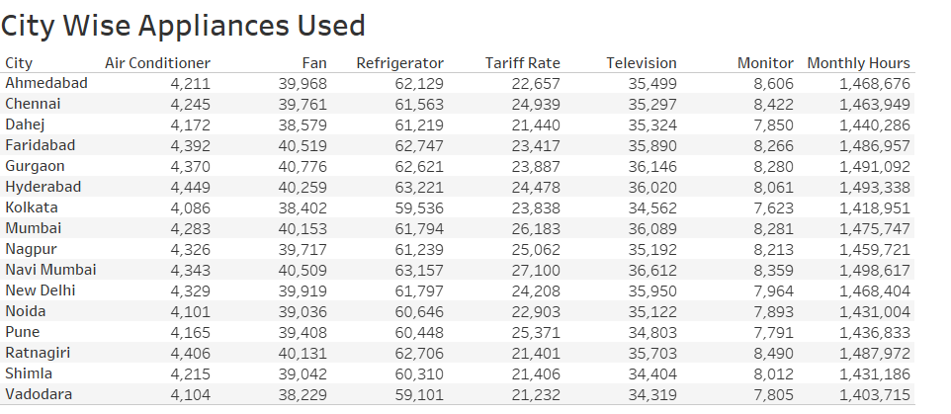

Our main aim to build this project is to provide user a good UI/UX to upload their dataset, select a target variable, choose a regression model such as ( Linear Regression ,Random Forest ,Decision tree), and visualize the performance metrics and predictions. In this we used Streamlit, Scikit-Learn, and Plotly libraries .

The key features to upload the dataset in CSV format and verify it before further proceedings. The platform will automatically create the correlation heatmap of all numeric features to understand relationship between them. User can choose three regressor model for evaluating Linear Regression ,Random Forest ,Decision tree for prediction and finding relationships . The platform will calculate the Mean Absolute Error (MAE), Mean Squared Error (MSE), Root Mean Squared Error (RMSE), Mean Absolute Percentage Error (MAPE), R² Score, and Adjusted R² Score. We can see Interactive visualizations i.e. (scatter plot of residuals vs predicted values, scatter plot comparing actual and predicted values).

Moving toward Technical implementation Data Preprocessing of numeric features in which Missing values are filled with the median and Categorical feature in which Missing values are filled using the most frequent value  and features are encoded using OneHotEncoder. Pipeline is created  to handle both numeric and categorical features. For Model training The dataset is divided into training and testing sets (80 train -20 test). Performance metrics are calculated to assess the model's accuracy in which selected model is trained on the training dataset and evaluated on the testing dataset. Streamlit is used for creating web applications with Python. Plotly is used for creating interactive visualizations, including scatter plots, bar charts, and heatmaps. Users can input values manually to generate predictions for electricity bills.

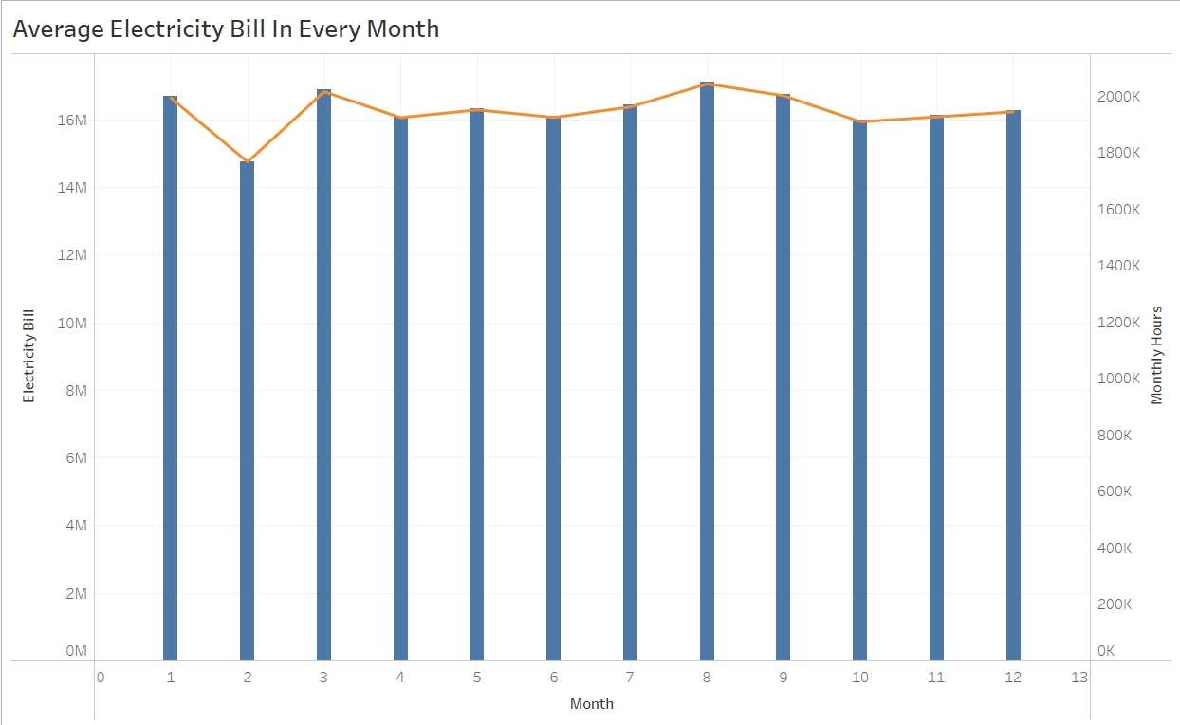

Result Analysis

Among the evaluated models, the Random Forest Regressor consistently perform better than other, achieving the lowest Mean Absolute Error (MAE) of 1.36 and Root Mean Squared Error (RMSE) of 5.38, which indicates highly accurate predictions with minimal error. The Decision Tree Regressor also demonstrates competitive performance but exhibits slightly higher error values, with an MAE of 1.77 and an RMSE of 9.65, suggesting a greater tendency for larger errors compared to Random Forest. In contrast, the Linear Regression model performs significantly worse, with a notably high MAE of 49.27 and RMSE of 70.56, revealing its inability to capture the underlying patterns in the data, leading to substantial prediction errors.

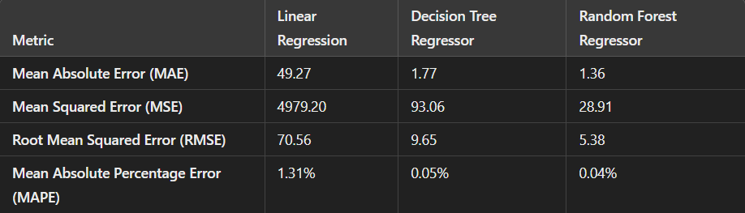

Energy consumption and forecasting plays a important role in household electricity management, enabling users to optimize usage and reduce costs. Our approach where users can input their budgeted electricity bill, and the system predicts the possible number of appliances they can use within our budget. The system takes inputs such as the number of months, average monthly operational hours, and the tariff rate per unit of electricity. Given a predefined budget for the electricity bill, the system adjusts the estimated number of appliances. For example, electricity budget of ₹5000, a tariff rate of ₹8.30 per unit, and 515 hours of monthly usage, the model predicts an estimated 13.88 fans can be used. This solution fosters better resource management and supports sustainable electricity consumption practices.

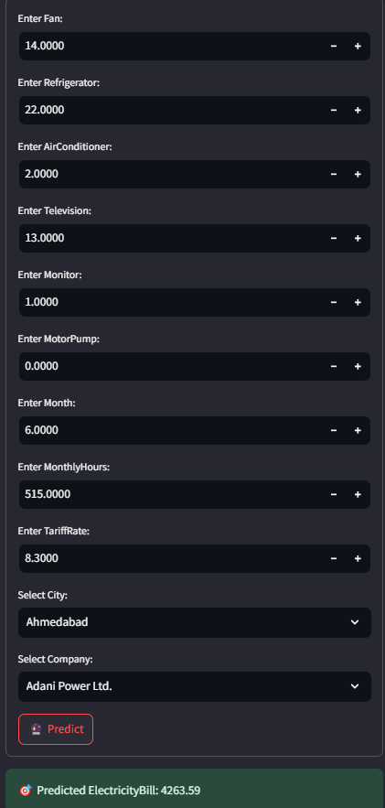 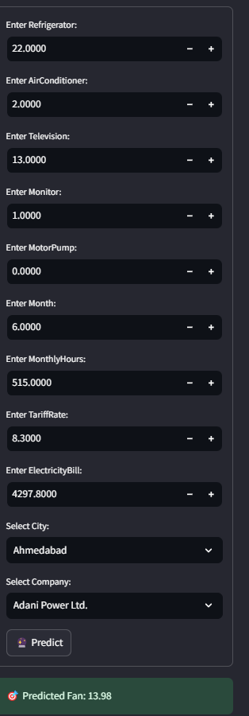

Conclusion

This research successfully demonstrates the effectiveness of machine learning models in predicting electricity bills and improving energy efficiency. By utilizing historical consumption data and advanced predictive techniques, our model enables households to forecast electricity costs accurately and adopt energy-saving measures. The findings highlight that ensemble models, particularly Random Forest outperform traditional regression methods in terms of accuracy. Furthermore, the integration of energy efficiency strategies, such as appliance optimization and demand forecasting, significantly contributes to cost reduction and sustainable energy consumption. This research lays the foundation for future advancements in smart energy management systems, potentially integrating real-time smart meter data and adaptive pricing strategies. Future work will explore enhancing model robustness with real-time data streams and expanding the system's applicability to industrial and commercial energy sectors.

References

|  |  |
| --- | --- |
|  |  |
| 1 | <https://www.energystar.gov/about/how-energy-star-protects-environment/energy-efficiency> |
| 2 | <https://www.sciencedirect.com/science/article/pii/S0301421516300878> |
| 3 | Kumar. J, C.R., Majid, M.A. Renewable energy for sustainable development in India: current status, future prospects, challenges, employment, and investment opportunities. Energ Sustain Soc 10, 2 (2020). https://doi.org/10.1186/s13705-019-0232-1 |
| 4 | <https://powermin.gov.in/en/content/energy-efficiency> |
| 5 | <https://www.sciencedirect.com/science/article/pii/S2666546822000441> |
| 6 | <https://www.sciencedirect.com/science/article/pii/S2667305323000017> |
| 7 | Tawalbeh, Nabeel, et al. "Demand Based Cost Optimization of Electric Bills for Household Users." International Journal of Communication Networks and Information Security 13.3 (2021): 376-381. |
| 8 | Hasan, Maha Yousif, Dheyaa Jasim Kadhim, and Amjad J. Humaidi. "Prediction of electricity-consumption and residential bills based on artificial neural network." International Review of Applied Sciences and Engineering (2024). |
| 9 | Wiesner, Hoël. "Optimizing the Electricity Bill. |
| 10 | Lazzeroni, Paolo, Gianmarco Lorenti, and Maurizio Repetto. "A data-driven approach to predict hourly load profiles from time-of-use electricity bills." IEEE Access 11 (2023): 60501-60515. |
| 11 | R. Teng and T. Yamazaki, “Load profile-based coordination of appliances in a smart home,” IEEE Trans. Consumer Electron., vol. 65, no. 1, pp. 38–46, 2018. |
| 12 | M. H. Rahim, A. Khalid, N. Javaid, M. Alhussein, K. Aurangzeb and Z. A. Khan, "Energy Efficient Smart Buildings Using Coordination Among Appliances Generating Large Data," in IEEE Access, vol. 6, pp. 34670-34690, 2018, doi: 10.1109/ACCESS.2018.2805849. keywords: {Home appliances;Peak to average power ratio;Pricing;Energy management;Schedules;Optimal scheduling;Smart grids;coordination;game theory;dynamic programming;big data}, |
| 13 | F. Etedadi Aliabadi, K. Agbossou, S. Kelouwani, N. Henao and S. S. Hosseini, "Coordination of Smart Home Energy Management Systems in Neighborhood Areas: A Systematic Review," in IEEE Access, vol. 9, pp. 36417-36443, 2021, doi: 10.1109/ACCESS.2021.3061995. keywords: {Topology;Energy management;Smart homes;Power system stability;Energy management systems;Systematics;Optimization;Coordination;decomposition;home energy management;neighborhood coordination;smart grids;demand response}, |
| 14 | Gorina, L., Korneeva, E., Kovaleva, O., & Strielkowski, W. (2024). Energy‐saving technologies and energy efficiency in the post‐COVID era. Sustainable Development, 32(5), 5294-5310. |
| 15 | W. Ahmed et al., "Machine Learning Based Energy Management Model for Smart Grid and Renewable Energy Districts," in IEEE Access, vol. 8, pp. 185059-185078, 2020, doi: 10.1109/ACCESS.2020.3029943. keywords: {Smart grids;Optimization;Renewable energy sources;Ground penetrating radar;Stochastic processes;Prosumer;smart grid;machine learning;energy districts;service level agreement;smart contract;optimization;Gaussian process regression;energy management model}, |
| 16 | Mhlanga, David. "Artificial intelligence and machine learning for energy consumption and production in emerging markets: a review." Energies 16.2 (2023): 745. |
| 17 | Adusumilli, Sri Bhargav Krishna. "TOWARDS ENERGY-EFFICIENT AIML INFERENCE ON EDGE DEVICES SOFTWARE SOLUTIONS AND CHALLENGES." Journal of Engineering Sciences 14.11 (2023). |
| 18 | Ukoba, K., Olatunji, K. O., Adeoye, E., Jen, T. C., & Madyira, D. M. (2024). Optimizing renewable energy systems through artificial intelligence: Review and future prospects. Energy & Environment, 35(7), 3833-3879. |
| 19 | Hamdan, A., Ibekwe, K. I., Ilojianya, V. I., Sonko, S., & Etukudoh, E. A. (2024). AI in renewable energy: A review of predictive maintenance and energy optimization. International Journal of Science and Research Archive, 11(1), 718-729. |